http://tradewins.com/Images_Custom/Dad_Legacy_CoverII.jpg

https://tradewins.com/ellie-taft/

https://tradewins.com/ellie-taft/dad%E2%80%99s-legacy-book-quick-start-cd/

Forex: The Mechanics by Ellie Taft
Currencies are traded in pairs. For example: the Euro versus the US Dollar (EURUSD).
You can find websites servicing all sorts of exotic currencies. The Euro versus the Polish Zloty (EURPLN), for instance, can be traded at Oanda.com. But, from a practical standpoint, you and I are better off sticking with the eight most actively traded currencies.
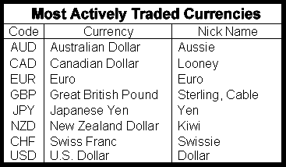
The first currency listed in a pair is the "Base" currency. The second is the "Counter" or "Quote" currency. The price tells you how many units of the second currency one unit of the first currency can purchase.
For example, if EURUSD = 1.3500 then you know you can exchange 1 Euro for $1.35 US.
When you go to the store, $.01 is the smallest amount of cash you can exchange for what you want. We simply don't have anything smaller than a penny.
But in the currency market, the smallest denomination is 100th of a penny… and it's called a "pip".
PIP stands for "Price Interest Point" and refers to the smallest incremental price a currency can change.
The Japanese don't use decimals in their everyday transactions. A cheap pair of shoes in Tokyo costs ¥3,500.
Hence, for the Japanese Yen, 1 pip = .01. For all other major currencies, 1 pip = .0001.
The Spread: What it is and why it is important
The spread is the difference between the price at which you buy (the Ask) and the price at which you sell, (the Bid).
Forex brokers don't generally charge commission. Instead, they make their money from the spread.
In addition to compensating the broker, a portion of the spread is absorbed by the market. Between the time a trader executes a trade and the time a market maker completes the transaction, there is often a price change- Sometimes it's to the market maker's benefit, but very often it's not.

The size of the spread therefore varies depending on the characteristics of a particular currency pair. Cross pairs tend to have bigger spreads because the transaction is handled in two parts.

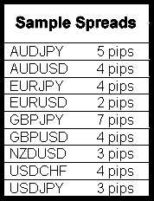

For example, if you placed an order to buy GBPJPY, the market maker would buy GBPUSD and buy USDJPY, multiply both rates and provide you with the resulting GBPJPY price.

Obviously, the tighter the spread, the better it is for you. And every FX broker claims to have "the tightest spreads in the industry".
But tight spreads are meaningful only when coupled with good execution. You'll find a comparison of various brokers in chapter X.
So there you have it boys and girls... the "Where", "When" and "What" of currency trading. That wasn't too tough, was it??

